

|  |
| --- |
| **Tool/Framework – Use Case Analysis**  Beneficiary’s Name, Designation – Domain |
|  |

Table of Contents

Introduction 3

TOOL/FRAMEWORK Tester Use Cases 3

• Add/Edit/Delete/View Test Cases 3

• Add Test Cases 3

• Edit Test Cases 3

• View Test Cases 3

• Delete Test Cases 3

• Use Case Diagram (TOOL/FRAMEWORK Tester Use Cases) 4

TOOL/FRAMEWORK Scenarios Use Cases 4

• Add Scenarios 4

• Delete Scenarios 4

• Start/Stop 5

• Pause/Abort 5

• Use Case Diagram (TOOL/FRAMEWORK Voice Scenarios) 5

TOOL/FRAMEWORK Test Execution Use Cases 5

• Description 5

• Tester Role: 6

• Manager Role: 6

• Use Case Diagram (TOOL/FRAMEWORK Test Execution Use Case) 6

# Introduction

Use case analysis is one of the most important and valuable requirement analysis technique we can leverage for clarifying and documenting the functional requirements of the Tool/Framework. A use case is a list of actions or event steps, typically defining the interactions between a role (known in the Unified Modeling Language as an actor) and a system, to achieve a goal. This document contains various use cases to capture the TOOL/FRAMEWORK Module functionalities.

# TOOL/FRAMEWORK Tester Use Cases

Tester of the Tool/Framework should be able to perform following operations:

### Add/Edit/Delete/View Test Cases

Tester will have a web based form to enter the following details:

|  |  |  |
| --- | --- | --- |
| **#** | **Field Name** | **Description** |
| 1 | BUSINESS CASE | Business Case node represents a set of callers in a specific condition or scenario. |
| 2 | MENU | A menu is defined as a message that introduces a set of Actions that can be selected by a key press |
| 3 | DATA | This is Test data value to be utilized by business case (Account number, locality etc.) |
| 4 | RELEASE | This field selected to specify test script belongs to which release |
| 5 | ACTIONS | This is name of method that performs specific set of actions |
| 6 | SPEAKIT | A SpeakIT is a message followed by a defined Next Action |
| 7 | CUSTOM CLASS | This field selected to specify test script belongs to which class |
| 8 | CLIENT CONFIG | This field selected to specify test script belongs to which config set |

### Add Test Cases

Tester will be able to design business flow test cases by selecting above fields and those test cases will be added in TOOL/FRAMEWORK repository.

### Edit Test Cases

Tester will be able to edit test cases of Tool/Framework and update according to voice scenarios.

### View Test Cases

Tester will be able to view test cases of Tool/Framework.

### Delete Test Cases

Tester will be able to delete test cases of Tool/Framework.

### Use Case Diagram (TOOL/FRAMEWORK Tester Use Cases)

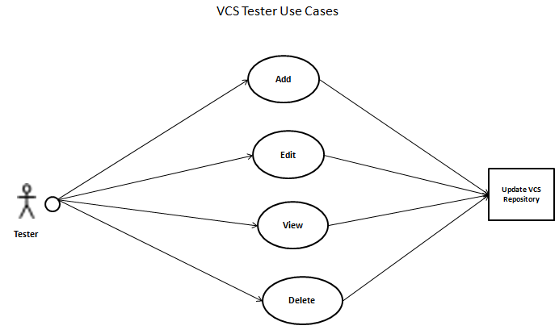

# TOOL/FRAMEWORK Scenarios Use Cases

Tester of the Tool/Framework should be able to perform following operations –

### Add Scenarios

Tester can create different client scenarios folder and can add corresponding scenarios under each business profile, below fields need to be populated.

|  |  |  |
| --- | --- | --- |
| **#** | **Field Name** | **Description** |
| 1 | Business Profile Name | Scenario belongs to which business profile |
| 2 | Environment | Scenario should run on which Environment |
| 3 | Scenario description | Gives idea about scenario belongs to which flow |
| 4 | Project Name | Scenario belong to which project |

### Delete Scenarios

Tester can delete scenarios folder or test case

|  |  |  |
| --- | --- | --- |
| **#** | **Field Name** | **Description** |
| 1 | Delete Scenario Folder | Tester can delete complete scenario folder |
| 2 | Delete Test Case | Tester can delete impacted test cases |

### Start/Stop

Tester will be able to start scenario execution or if issue occur then scheduled scenarios can be stopped.

### Pause/Abort

Tester will be able to pause or abort scenario execution at any point of time.

### Use Case Diagram (TOOL/FRAMEWORK Voice Scenarios)

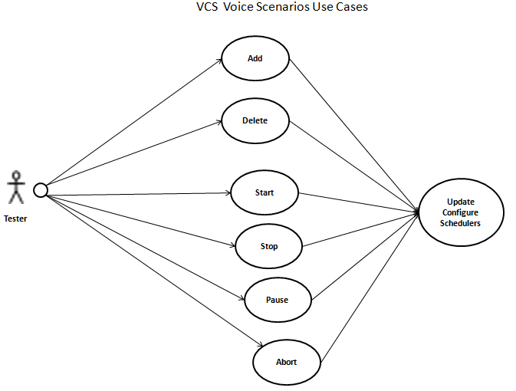

# TOOL/FRAMEWORK Test Execution Use Cases

### Description

TOOL/FRAMEWORK Test Execution Use Cases gives you an idea for Tester and Manger role use cases. Tester of the Tool/Framework should be able to perform different operations such as create test cases/ execute scenarios/verify result/delete result, etc. and Manager will be able to generate see different project reports.

### Tester Role:

1. Tester will design test cases with the help of Input Test Script File Builder UI Module or provide UML as an input to TOOL/FRAMEWORK Input Unit Module.
2. Test generator will generate all the possible test cases.
3. Tester will pull all the required test case under scenario folder.
4. Test Scenarios will be scheduled according to configured time.
5. Processing Unit Module will process the scheduled test cases.
6. Execution Unit Module will pull all the required information such as Business configurations and Business Rule according to test cases and execute voice flows and will validate all the voice test cases against voice application.
7. Output Unit Module will generate desired output formal file mentioned in TOOL/FRAMEWORK Configurations.
8. Tester will be able to verify results.

### Manager Role:

1. Manager will be able to generate see different project reports such as -
   * Execution progress
   * System performance
   * Audios reports
   * Past reports for analysis
   * Call drop analysis report
   * Monitor real time voice channel report, four types of summary reports:
   * Feature
   * Load
   * Monitoring
   * Sub Reports etc.

### Use Case Diagram (TOOL/FRAMEWORK Test Execution Use Case)

